SANKALP RONGE
SAP ID: 590027268
BATCH =77
LINUX ASSIGNMENT 1

Activity 1: Create a directory called MyLinuxFiles in your home folder. Inside it, create three files named file1.txt, file2.txt, and file3.txt. Display the list of files with detailed information.
Commands used:
• mkdir – used to create a new empty directory
• touch – used to create a new file
• ls -la – used to show detailed information of a file(s)
• cd – used to navigate the file system
Screenshot :
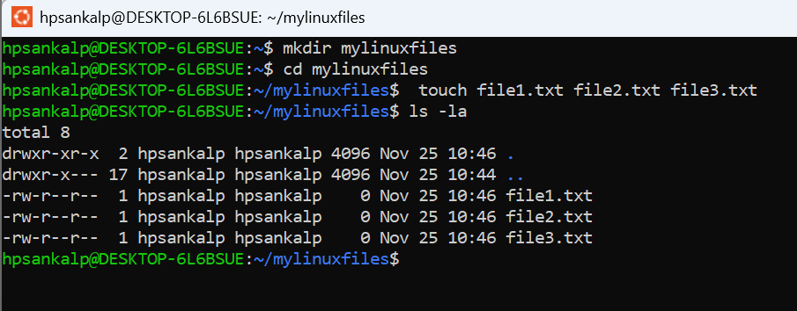

Activity 2: Change the permissions of file1.txt so that the owner can read and write, the group can read only, and others have no access.
Verify the permission.

Commands Used:
• chmod NNN filename – used to change the permissions of a file or directory.
{N = sum of numeric values of permissions}
• ls -la filename – used to show detailed information of a file(s)
Screenshot:
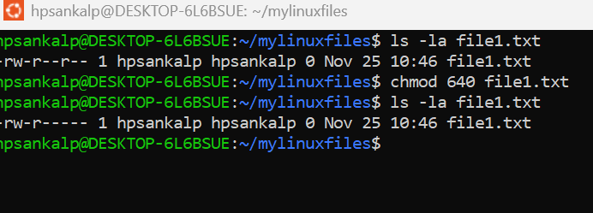

Activity 3: Create a directory called MyLinuxFiles in your home folder. Inside it, create three files named file1.txt, file2.txt, and file3.txt. Display the list of files with detailed information.

Command Used:
• grep [pattern] filename – used to search a given pattern in a file
Screenshot:
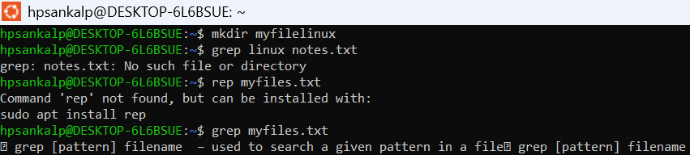

Activity 4: Write a command to display the contents of file1.txt, and save the sorted output into a file named sorted.txt.
Commands Used:
• cat filename – used to view file content
• sort filename – used to arrange lines of text in a file in alphabetical or numerical order
Screenshot:
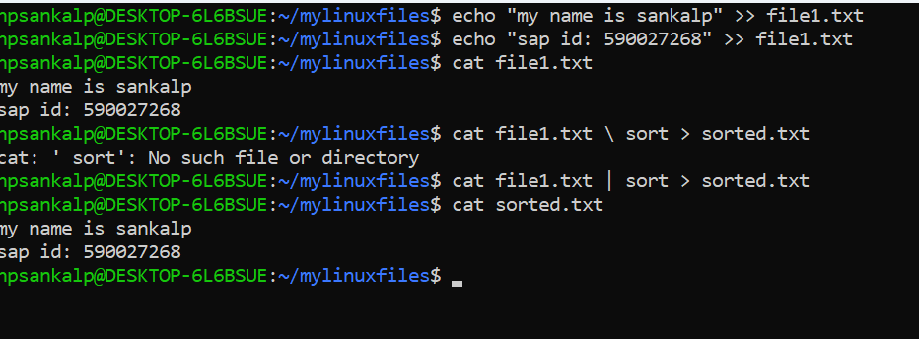

Activity 5: Write a shell script that takes two numbers as input from the user and prints their sum, difference, product, and quotient. Handle division by zero appropriately.

Commands used:
• vim – editor used to create the shell script - {arithop.sh}
• chmod NNN filename – used to change the permissions of {arithop.sh}
{N = sum of numeric values of permissions}
• bash filename – used to run the shell script - {arithop.sh}

Screenshot:
Script>
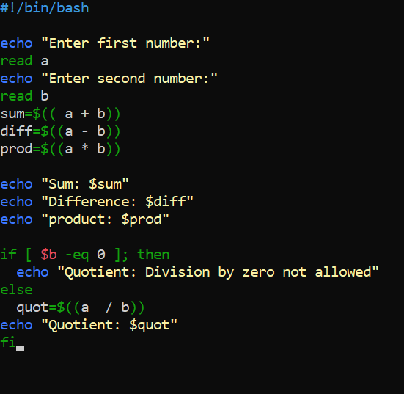

TERMINAL
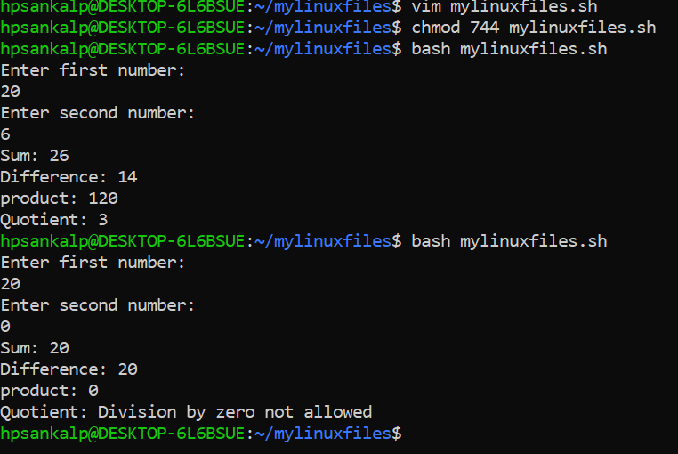
Activity: Use the find command to search for all .txt files in your home directory that were modified in the last 7 days.

Command used:
• find [path] [options] [expression] – used to search for files in the home directory
• -mtime -n – used with find to search for files modified in the last 7 days
{n = no. of days}

Screenshot:
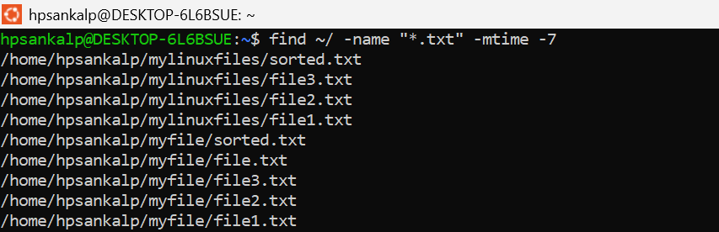
Explanation of the command : find ~/ -name “*.txt” -mtime -7
• find ------ command used to search for files/directories
• ~/ -------- search inside your home directory
• -name "*.txt" --------- look for files ending with .txt
• -mtime -7 -------- only files modified within the last 7 day

Activity 7: Create a compressed archive of the directory MyLinuxFiles using tar and gzip. Then extract it to verify its contents.
Commands Used:
• tar [options] {archive_name} [files or dir] – used to create a compressed archive

Screenshot: 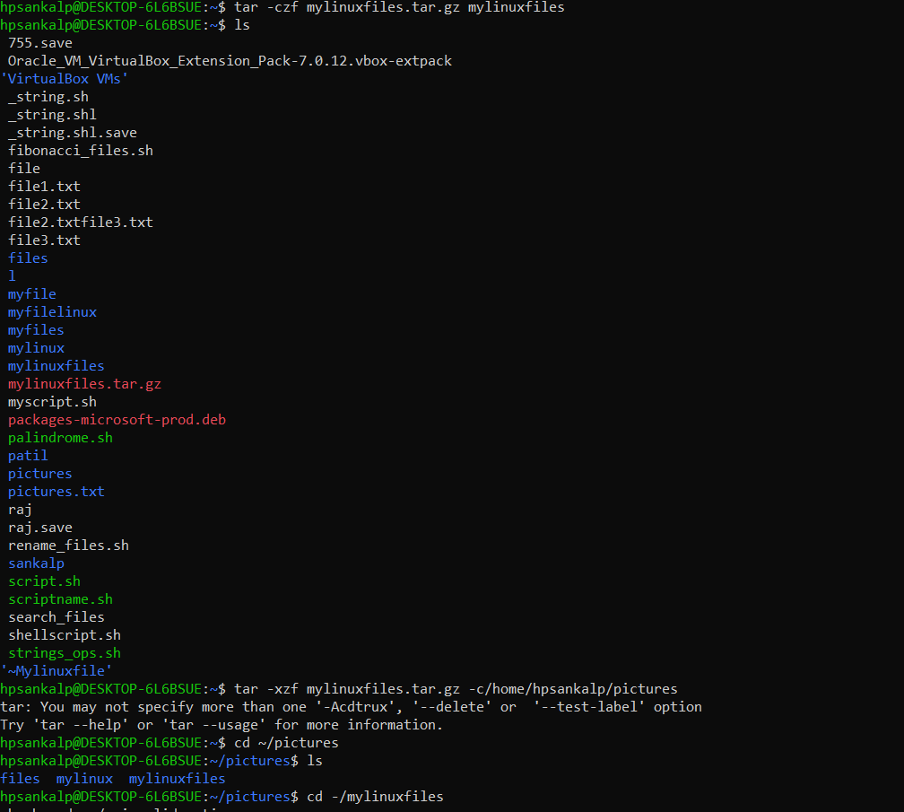

Explanation of the command : tar -czf MyLinuxFiles.tar.gz MyLinuxFiles
• tar -czf --------- create a compressed (gzip) archive file
• MyLinuxFiles.tar.gz ---------- the name of the archive that will be created
• MyLinuxFiles ---------- the directory we want to archive

Explanation of the command:
tar -xzf MyLinuxFiles.tar.gz -C /home/hpsankalp/Pictures
• tar -xzf --------- extracts a gzip-compressed .tar.gz archive
• MyLinuxFiles.tar.gz ---------- the archive file to extract
• -C ---------- change to the specified directory before extracting
• /home/vivekchauhan12/Pictures ----------- the directory where the files will be extracted

Activity 8: Display the IP address of your system. Use ping to check connectivity to google.com .
Commands Used:
• ifconfig – used to displays your system’s IP address, netmask, broadcast, and network interface status.
• ping – tests network connectivity by sending packets to a host & checking if replies come back
Screenshot:
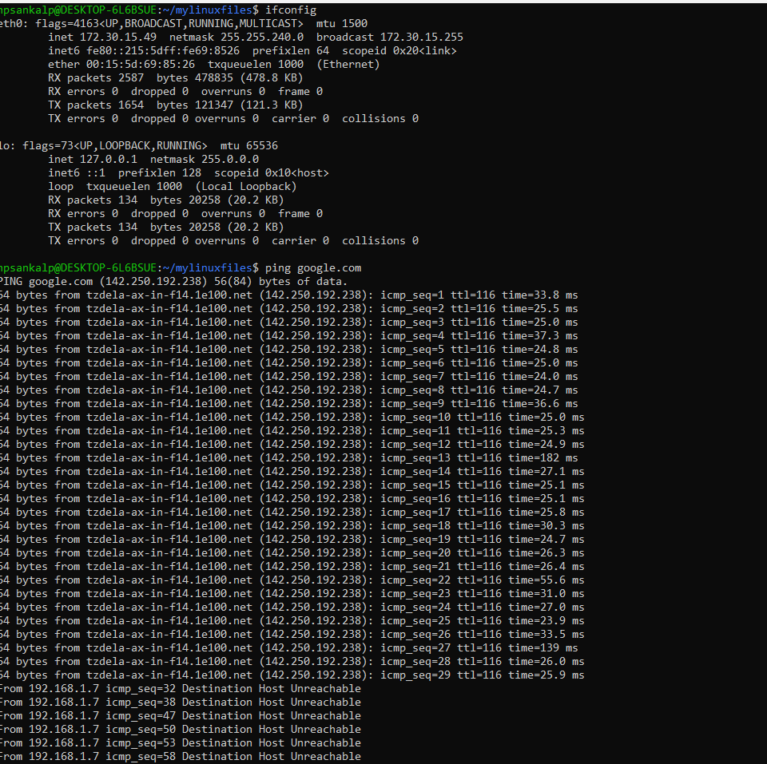
Activity 9: Write a program to find the largest number among three numbers entered by the user.

Commands used:
• vim – editor used to create the shell script - { largestnum.sh}
• chmod NNN filename – used to change the permissions of { largestnum.sh}
{N = sum of numeric values of permissions}
Screenshot:
Script>
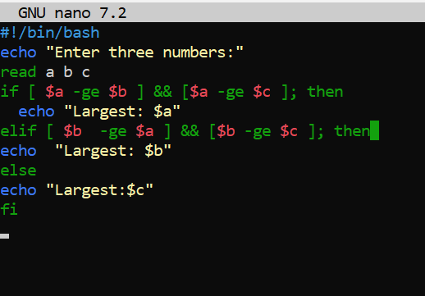
Terminal
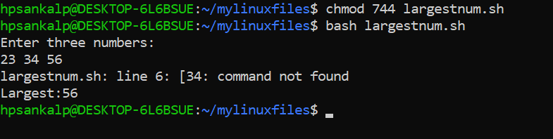

Activity 10: Write a program to find the sum of the first N natural numbers.
Commands Used:
• vim – editor used to create the shell script - { sumN.sh}
• chmod NNN filename – used to change the permissions of { sumN.sh}
{N = sum of numeric values of permissions}
• bash filename – used to run the shell script - {sumN.sh}
Script:

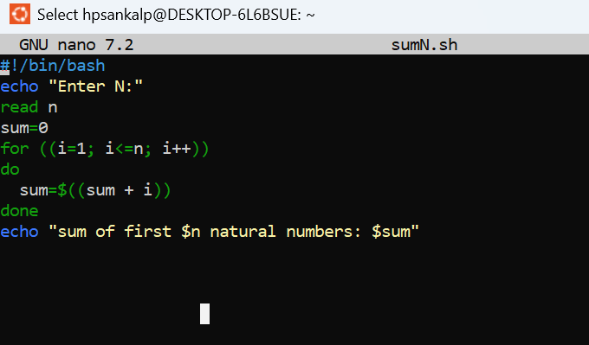
Terminal
